Challenges Faced:
"Despite my unfamiliarity with blockchain and app development, I embraced the challenge of building a decentralized lending DApp.
Time constraints pushed me to swiftly learn blockchain, Ethereum, Solidity, and React. The days were so hectic and rewarding too.
Despite my unfamiliarity ,I delivered a functional DApp, showcasing my hustler nature, dedication and adaptability."
It was quite interesting project/assignment to work upon, paving my way in the field of app/web dev, Block-chain and Decentralized Finance. 😊😁

Lets see the Gradual Progress :) ..
Testing in Remix of the Solidity File :
1. (Start-> Contract Balance: 0 )
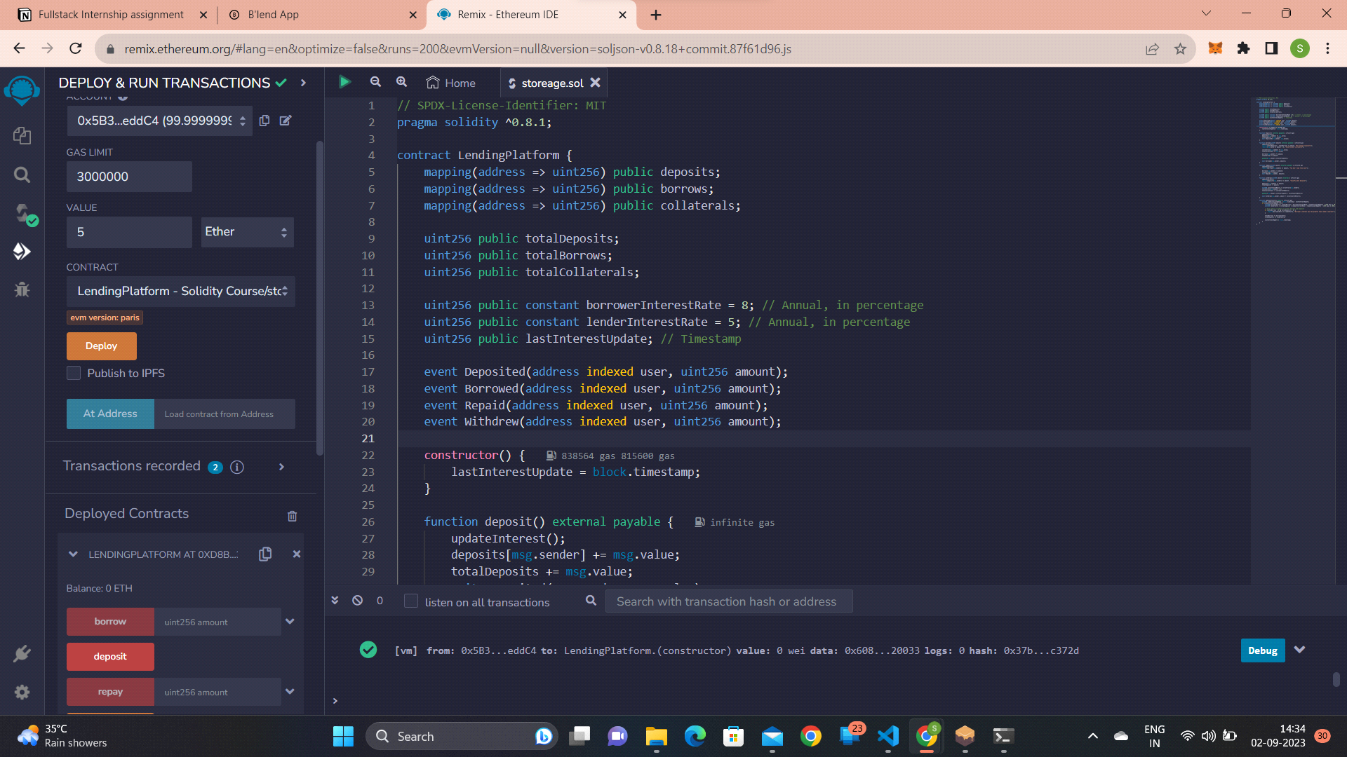
2. (Deposited 5 ETH now-> Contract Balance: 5ETH )
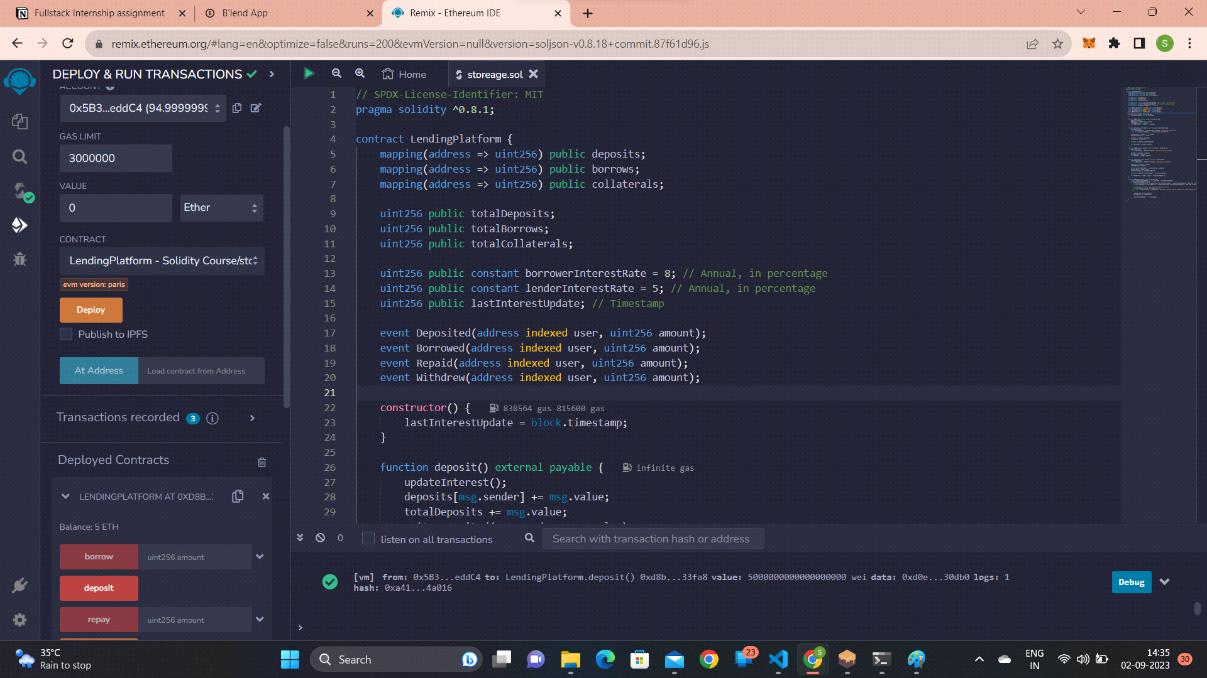
3. (WithDrew 2 ETH or 1,000,000,000,000,000,000 wei now-> Balance: 3 ETH )
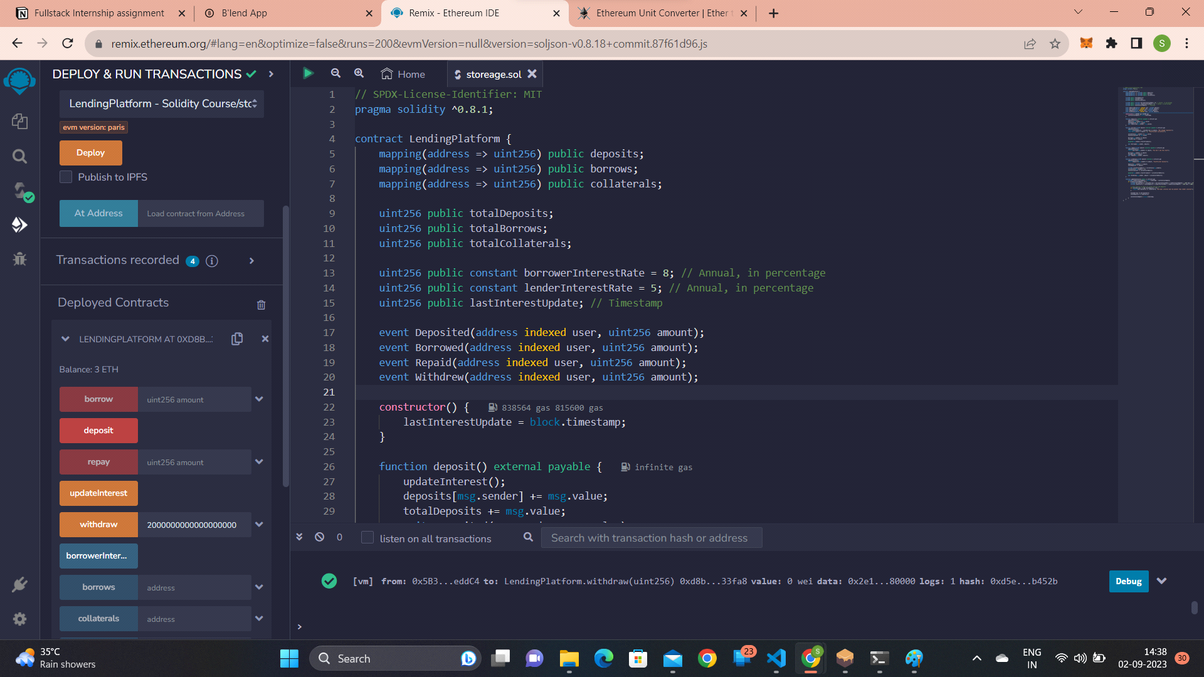
4. Other Functions like TotalDeposits, Total Borrow, Last Interest Timestamp Update,
Total Collaterals also working fine... 😊😉😍😁👌
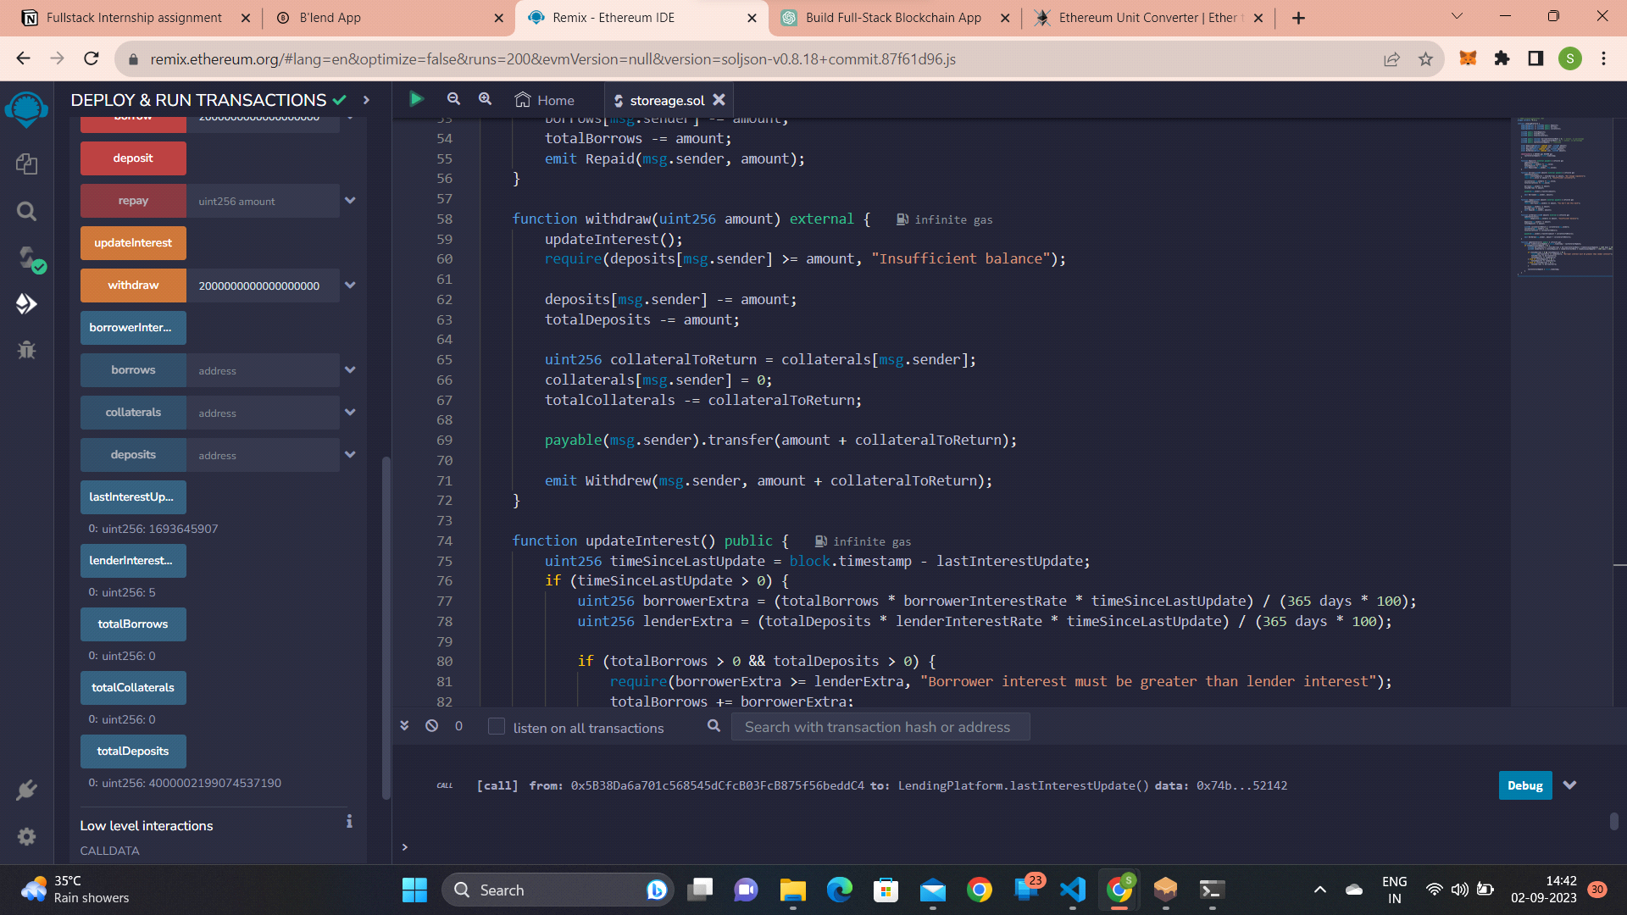

Transactions in Ganache Local Network: (primitive front end)
1. Event Lend (8)
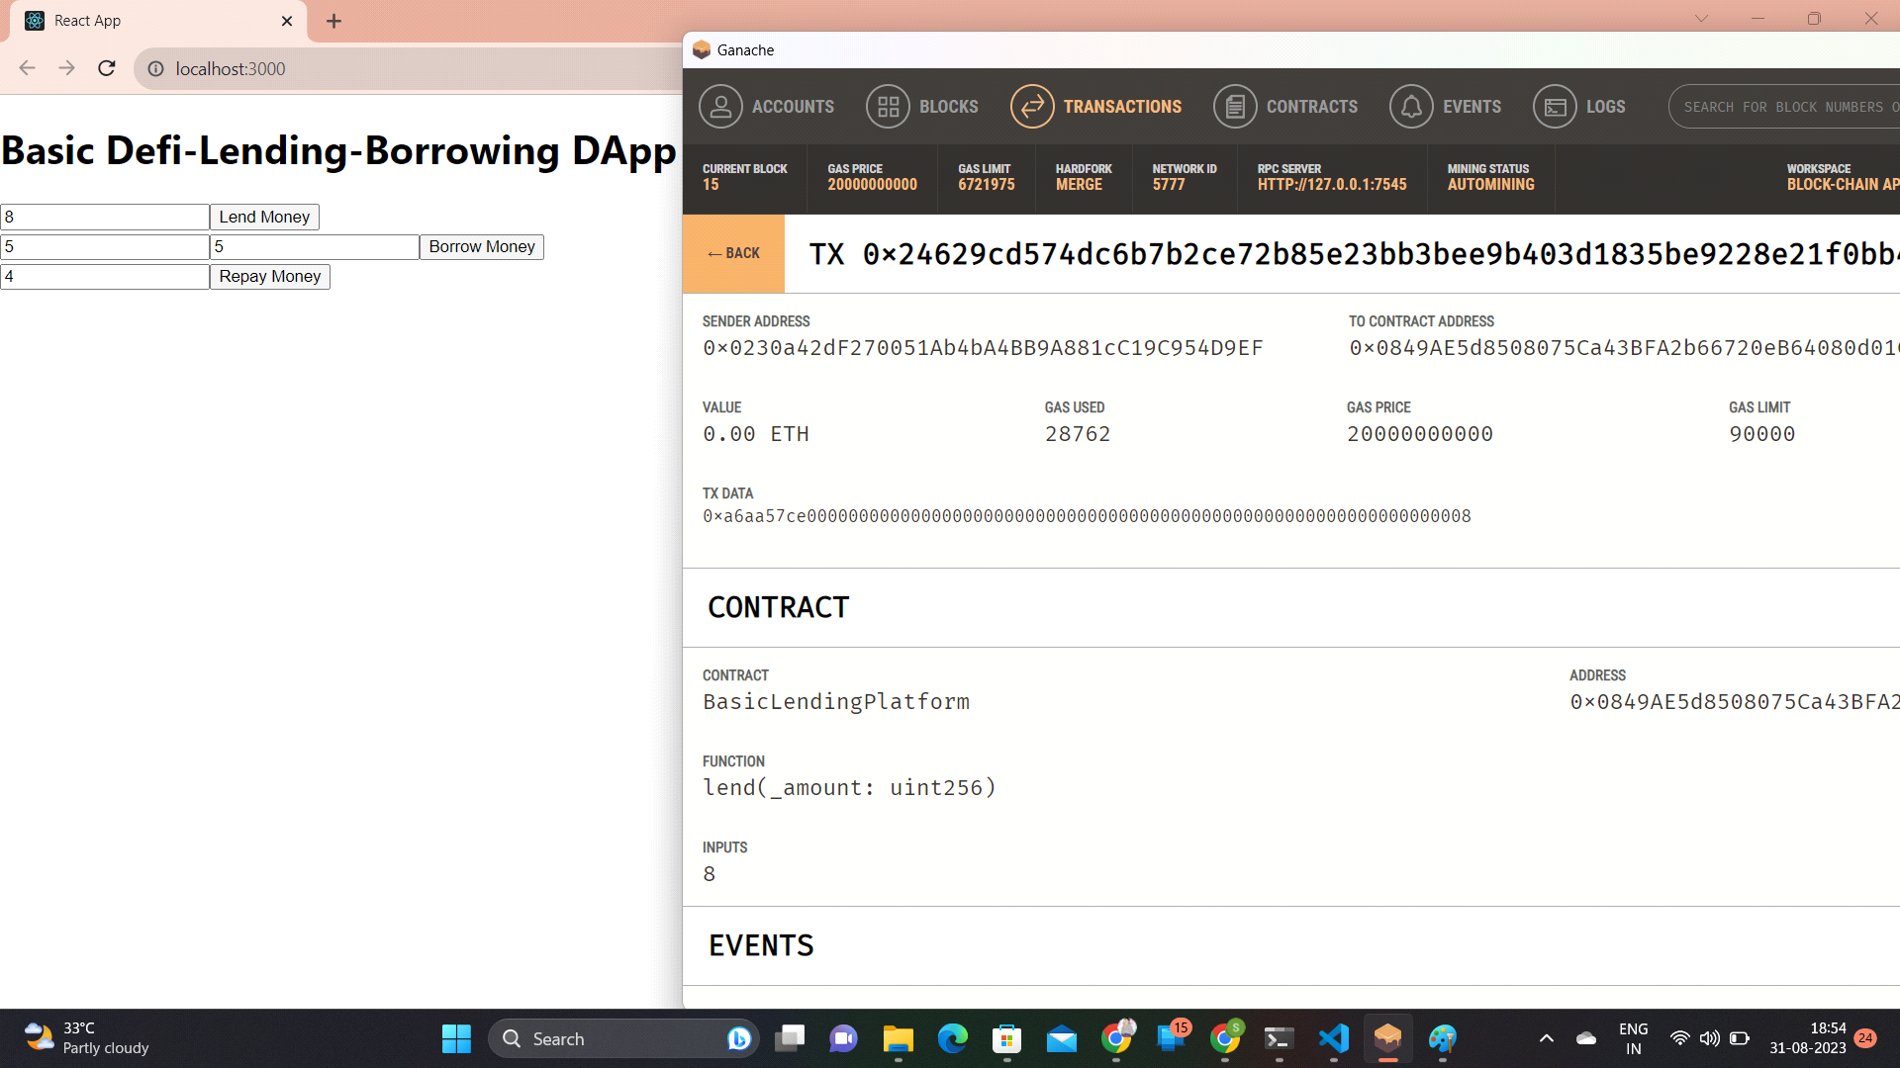

2. Event Borrow (4,4)
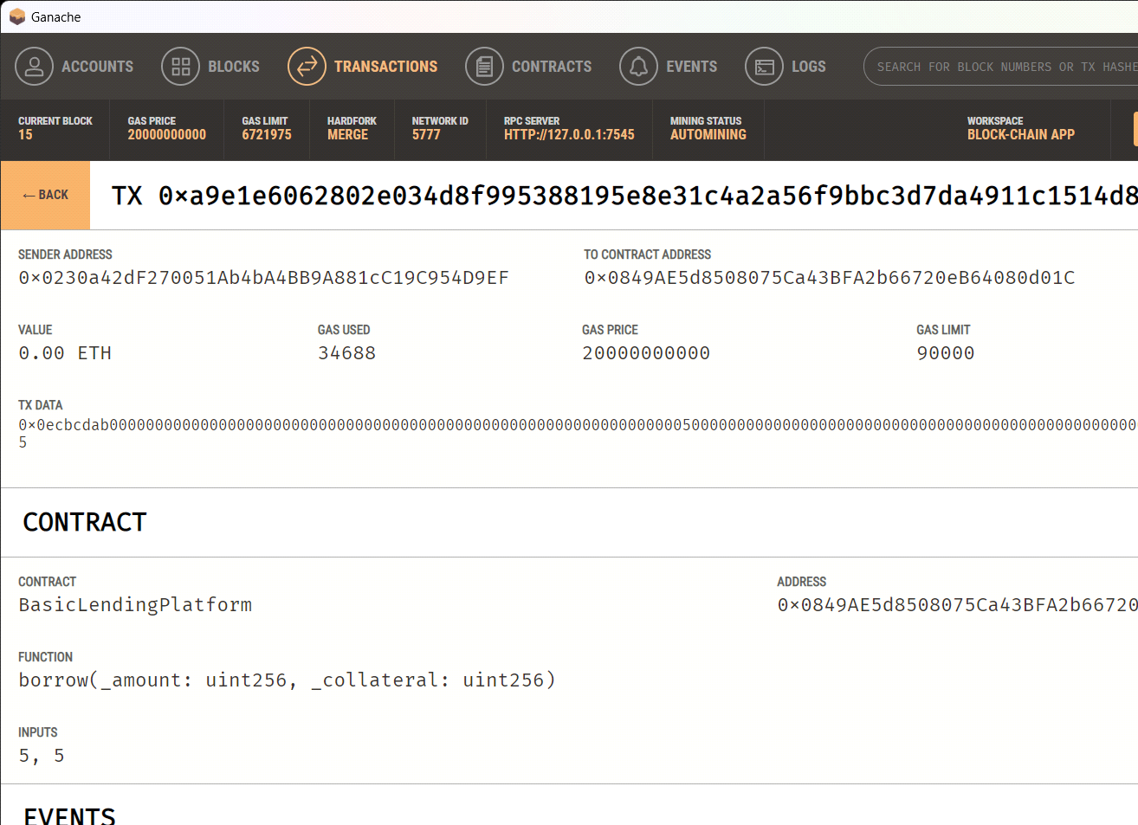

3. Event Repay (4)
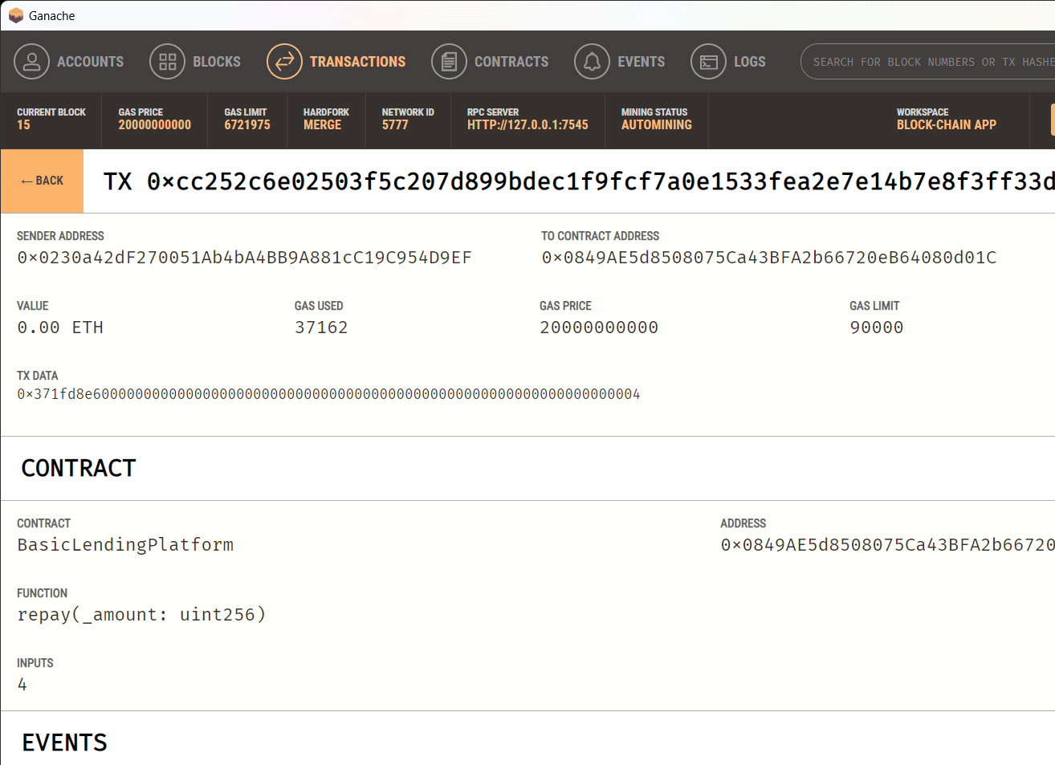

Now with MetaMask Wallet:
                - Connected with MetaMask Wallet.
                - Imported Tokens in MetaMask wallet from Ganache.
                - Improved Front End added feature to see balance and Address, still kept it a basic one.
                - Fixed the Value amounts for Deposit, Borrow, Repay and WithDraw to reduce the user effort-less and preventing out-lier input failures.

1. Request Pop-up for .1ETH Deposit
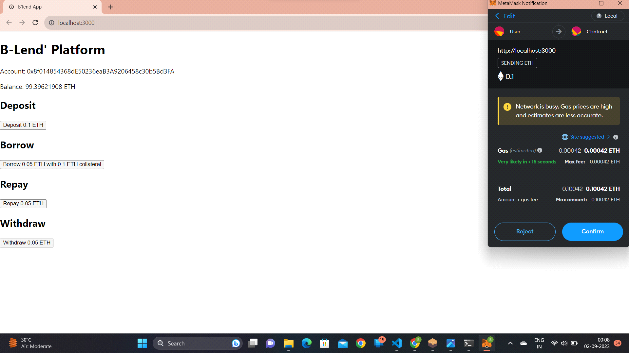

2. Success Deposit of .1ETH (Note: Balance updates with page Refresh)
